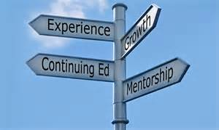Name_______________________________ Journal Entry #___________

Date________________________________

I used the following article URL: ______________________________________________

NO COPY AND PASTING

TOPIC:_____________________________________________

Poor Average Excellent

1. Who is the article about? 1 2 3 4 5
2. What is the article about? 1 2 3 4 5
3. Where does this article take place? 1 2 3 4 5
4. When does this article take place? 1 2 3 4 5
5. Why was this article published? 1 2 3 4 5
6. How do you personally feel after 2 4 6 8 10

reading this story? What have you

learned?

1. Proper use of grammar and 2 4 6 8 10

punctuation?

Total Points_______/45

I used the following article URL: ______________________________________________

NO COPY AND PASTING

TOPIC:_____________________________________________

Poor Average Excellent

1. Who is the article about? 1 2 3 4 5
2. What is the article about? 1 2 3 4 5
3. Where does this article take place? 1 2 3 4 5
4. When does this article take place? 1 2 3 4 5
5. Why was this article published? 1 2 3 4 5
6. How do you personally feel after 2 4 6 8 10

reading this story? What have you

learned?

1. Proper use of grammar and 2 4 6 8 10

punctuation?

Total Points_______/45